  - Fear & Joy Project article as published in CIfAs ‘The Archaeologist’ magazine in June 2026 (TA128).

A toolkit for change and the fear of change within a profession in flux
At the 2025 European Association of Archaeologists (EAA) conference, we ran a workshop exploring the small, everyday fears that arise as the archaeological profession evolves. Our aim was to create space for honest reflection, encourage openness, and begin shaping a “solutions kit” that supports practitioners in navigating change with confidence and compassion.
The workshop invited participants to share challenges and positive experiences, focusing on group psychology, self-worth, and community support. This article outlines the workshop’s outcomes and the early framework for the solutions kit.

Methodology
Due to civil unrest in Serbia, EAA2025 moved online. With support from colleagues, we adapted the workshop into two two-hour virtual sessions. The group was intentionally small to ensure everyone had space to speak freely.
The wider conference context — including discussions relating to the Israeli-Palestinian conflict — added complexity but also relevance, as participants reflected on fears and concerns within the profession and beyond.
The workshop followed guiding principles centred on kindness, patience, active listening, respect, and confidentiality. Participants shared experiences anonymously using an online collaboration board.

Workshop structure
- Part One: Small fears and negative reactions to change
- Part Two: Joy, nourishment, and positive experiences in archaeology
The order was intentional: we wanted to acknowledge difficult emotions without leaving participants in a negative space.

Results — Small Fears (see image 1)
Three ideas shaped the discussion:
- Archaeologists often feel like non-conformists who must conform.
- Fear arises from many sources and situations.
- Self-reflection is essential: What could I do better?
Participants described fears and challenges including:
- Feeling boxed in or constrained
- Being judged or dismissed
- Cognitive dissonance around the “big lie” that struggle equals worth
- Small fears accumulating into major obstacles
- Rigid or stifling workplace cultures
These experiences resonated widely — many practitioners share similar concerns.
Image 1- Areas where workshop participants have experienced small fears and/or challenges, grouped into headline themes.
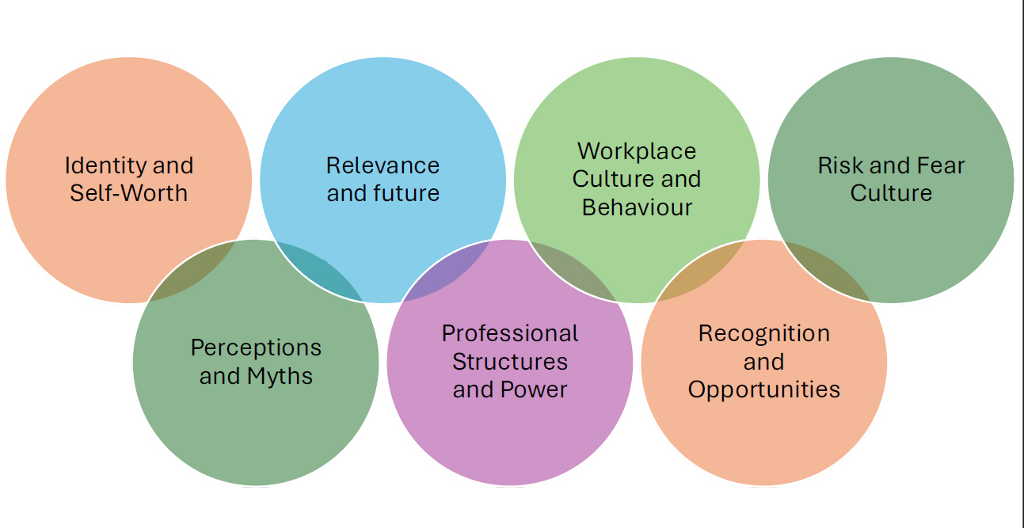

Suggested solutions
Participants proposed ways to support themselves and others:
- Honest exploration of challenges
- Combating isolation
- Creating safe spaces for openness
- Extending respect to non-professionals
- Promoting bravery, self-worth, and diversity of thought as core skills

Results — Joy and Nourishment (see image 2)
The joy-focused discussion centred on two ideas:
- Joy expands our world.
- It is possible to take pride in archaeology while still prioritising others.
Participants reflected on sources of joy such as:
- Exploration and discovery
- Sharing knowledge
- Belonging and giving back
- Unique professional experiences
- Helping others
- Connecting with peers and communities
Image 2- Areas where workshop participants find joy and nourishment, grouped into headline themes.
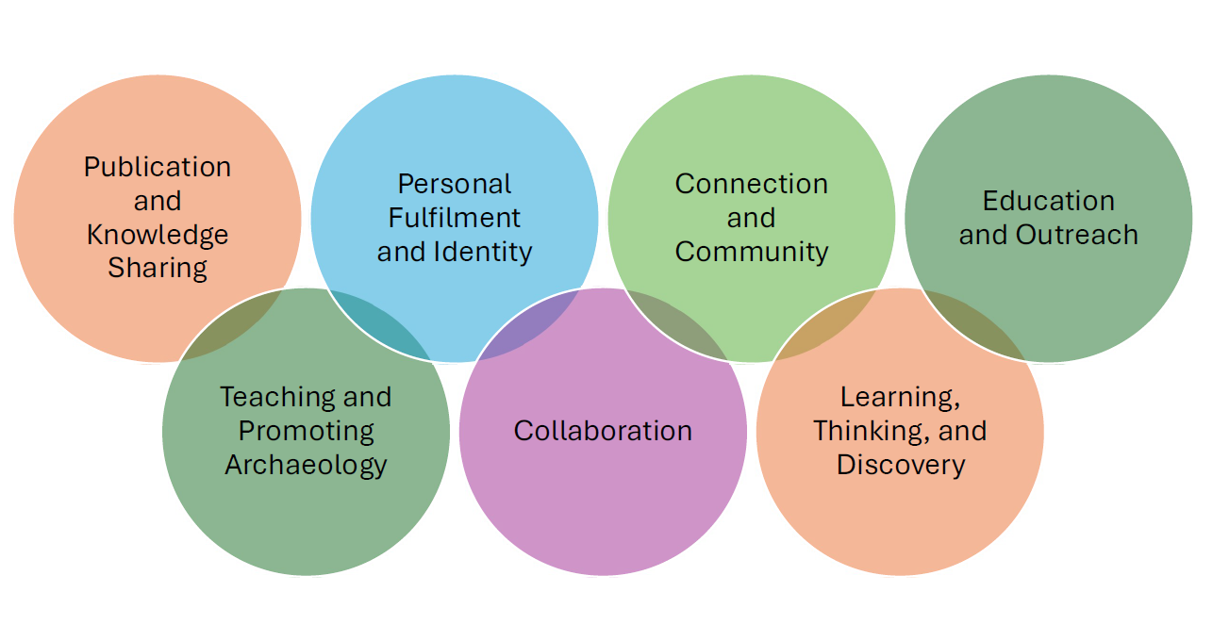

Barriers to joy
Many participants had experienced obstacles to joy. They suggested:
- Encouraging diverse thinking
- Sharing joy publicly, not only results
- Being open about failure
- Finding courage through community

Solutions Kit — Early Framework (see image 3)
The developing solutions kit aims to help practitioners navigate fear, embrace joy, and build resilience. It will focus on:
- Community building
- Training that emphasises ways of thinking and diversity
- Promoting safe culture, reporting, and accountability
- Skills for respect, self-worth, and healthy boundaries
- Understanding archaeology as a vocation
- Speaking up and speaking out
This work will continue through future events and collaboration across the profession.
Image 3- Key themes of the potential solutions highlighted by workshop participants to resolve the barriers they find to experiencing joy within the profession.
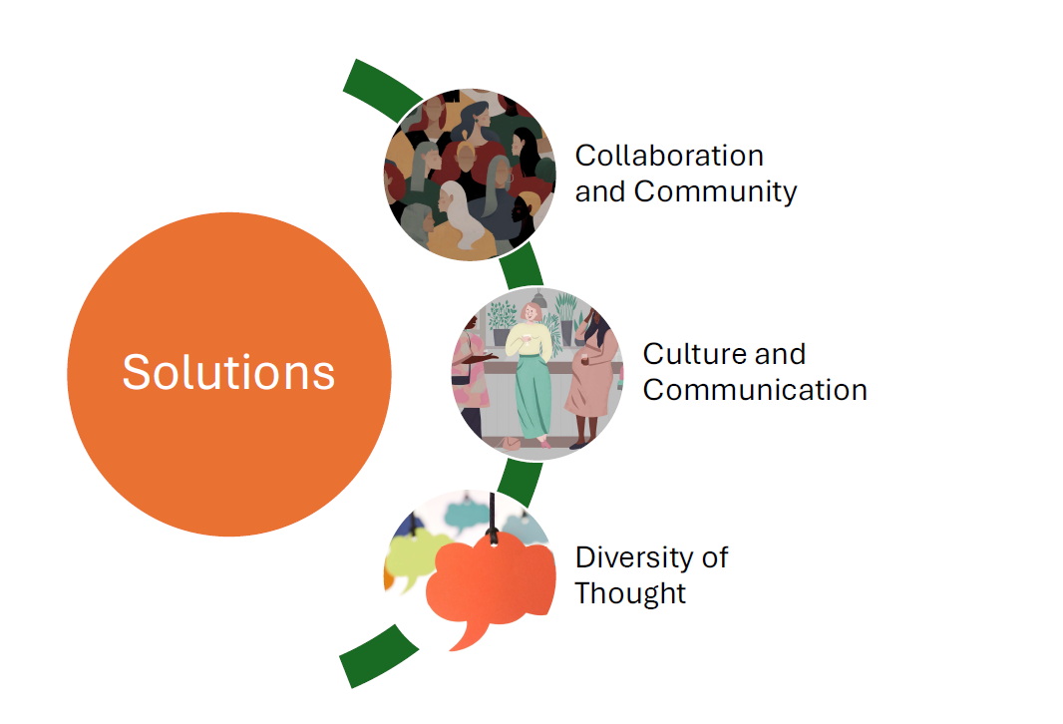

Conclusions
The workshop did not reveal new ideas about fear, joy, or challenge in archaeology — but it illuminated a space we often avoid: ourselves, and how we behave as a community. It reinforced a simple truth: together is more fun.
The workshop marks the beginning of a longer journey. Developing the solutions kit will require collaboration across the profession and honest self-reflection. As one participant quoted:
“I’m the problem, it’s me.”

About the Authors
Emily Plunkett MCIfA Senior heritage specialist at the Environment Agency (NEAS), with 20 years’ experience across commercial archaeology and government bodies. Research interests include improving professional practice and workplace culture.
Mark Spanjer MCIfA Lecturer at Saxion University of Applied Sciences, with experience across multiple forms of archaeological practice in the Netherlands. His work focuses on understanding archaeologists themselves to improve professional wellbeing.

